









RISHAB CHAKRABARTI

102003688



MOVIE DIRECTOR ANALYSIS

DASHBOARD

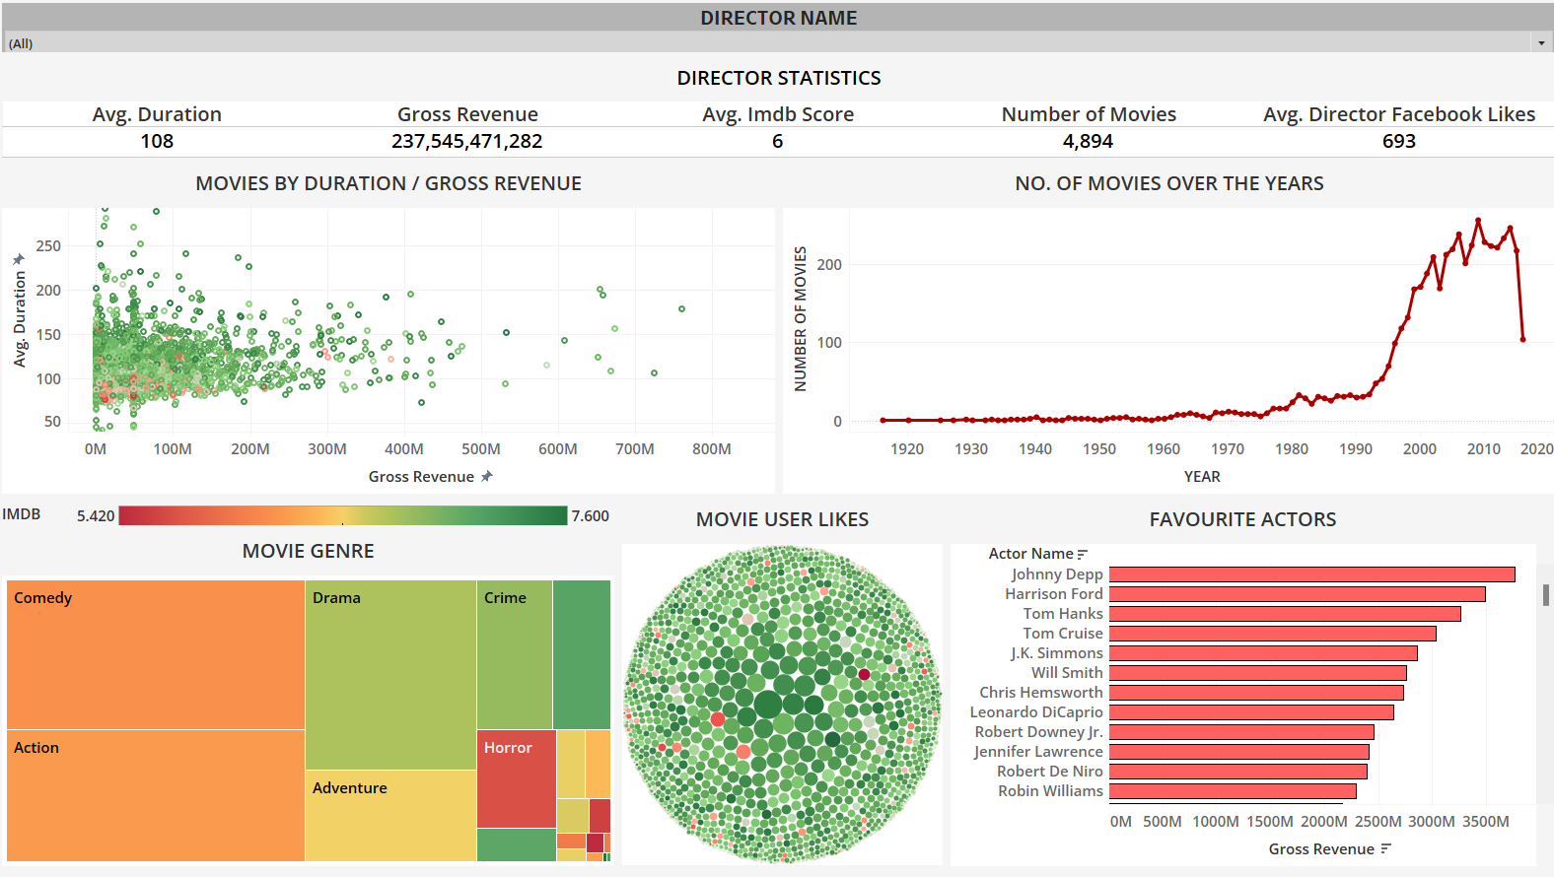

TABLE SPLITTING AND MERGING

1.TABLES BEFORE MERGE

TABLE 1

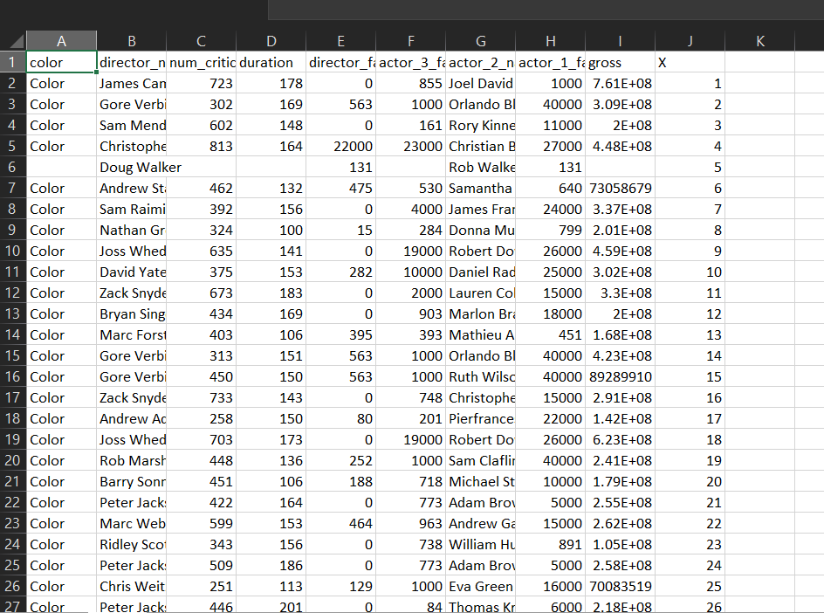

TABLE 2

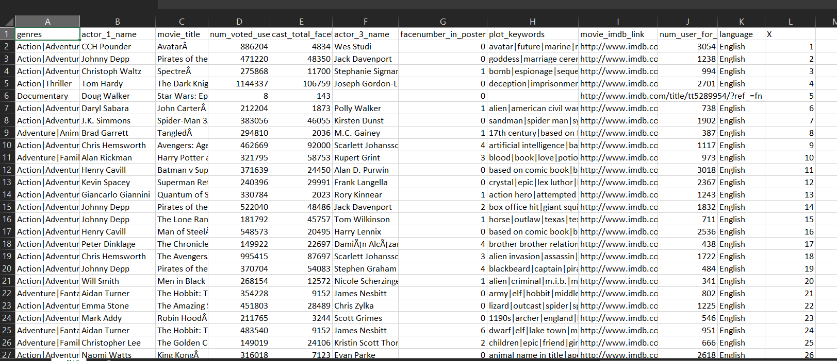

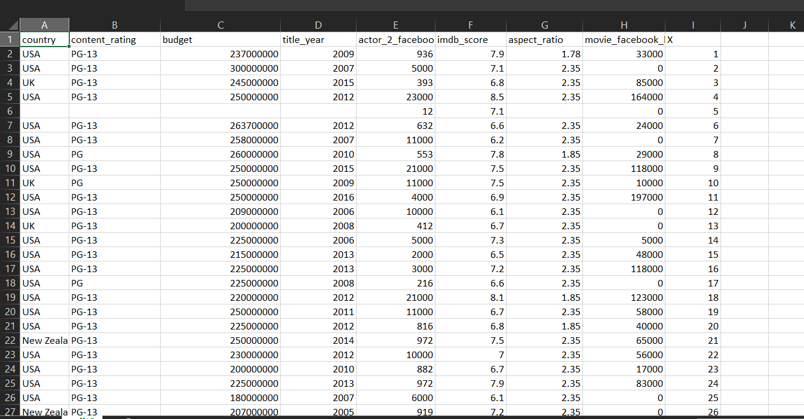TABLE 3

JOINIING THE 3 TABLES

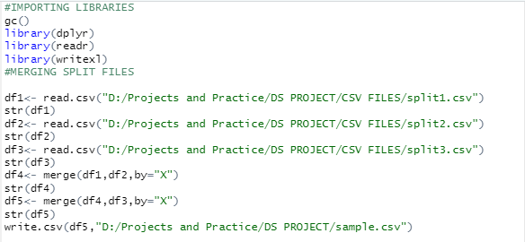R CODE

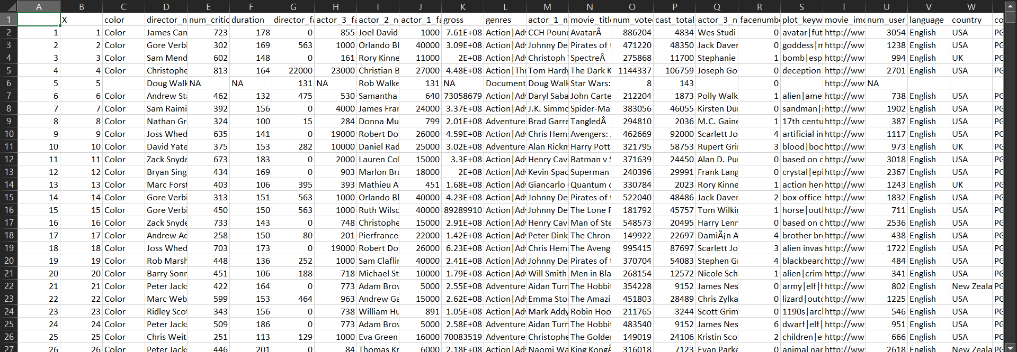OUTPUT

CLEANING THE DATA ON THIS COMBINED DATASET

1.READING THE FILE AND REMOVING FIRST 2 ROWS

R CODE

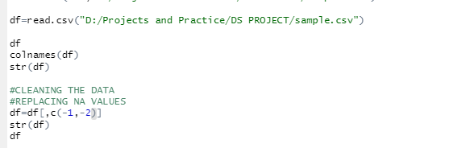

2.REPLACE THE STRING COLUMNS BY MODE OF COLUMN

R CODE

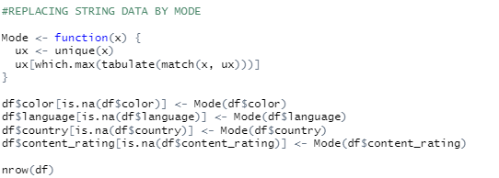

3. AS DIRECTOR NAME IS CRUCIAL IN ANALYSIS, RECORDS HAVING NULL VALUES IN DIRECTOR NAME ARE DROPPED

R CODE



4.REPLACING COLUMNS HAVING NUMERIC VALUES WITH THE MEAN OF THE RESPECTIVE COLUMN

R CODE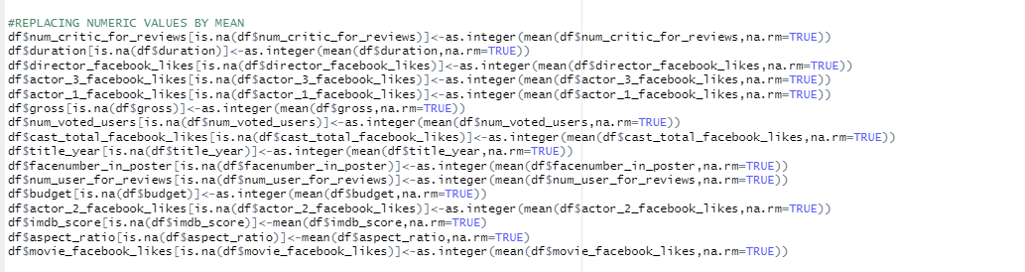

5.CHECKING FOR NULL VALUES IN EACH COLUMN

R CODE



OUTPUT

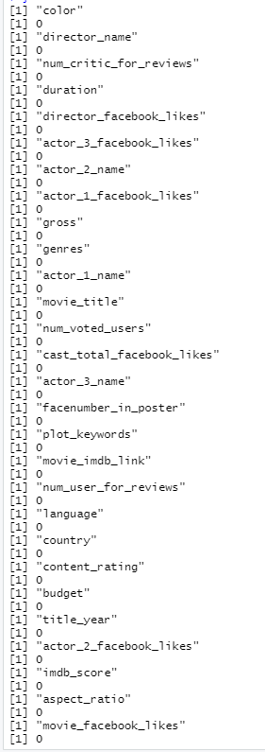

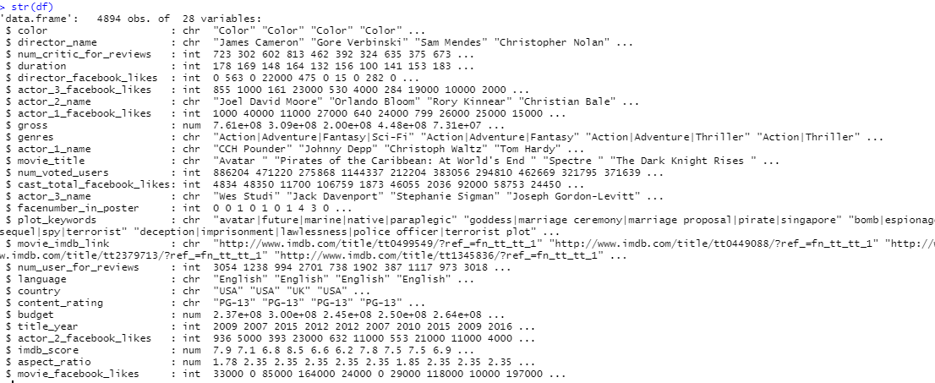

6. EXPORTING FINAL DATA

R CODE



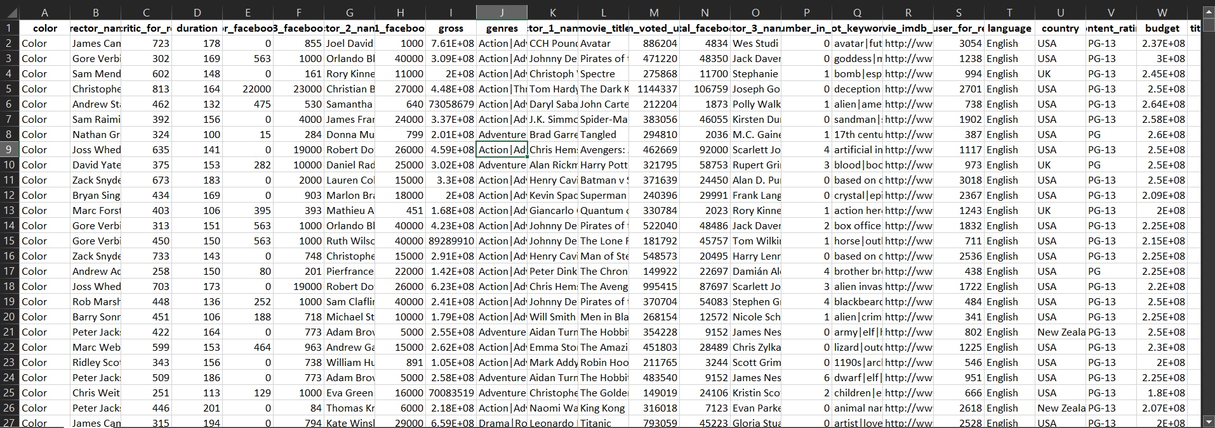OUTPUT

FINAL.XLSX

TABLEAU QUERIES

ALL QUERIES HAVE BEEN FILTERED ACCORDING TO DIRECTOR WISE

1. WHAT IS THE STATISTICS OF THE DIRECTOR IN TERMS OF DURATION OF MOVIE, AVG IMDB SCORE , GROSS REVENUE, NUMBER OF MOVIES AND PEOPLE LIKELINESS



1. DOES THE GROSS REVENUE DEPEND ON THE DURATION OF THE MOVIE AND THE IMDB SCORE ATTAINED BY THE MOVIE IN THE BOX OFFICE

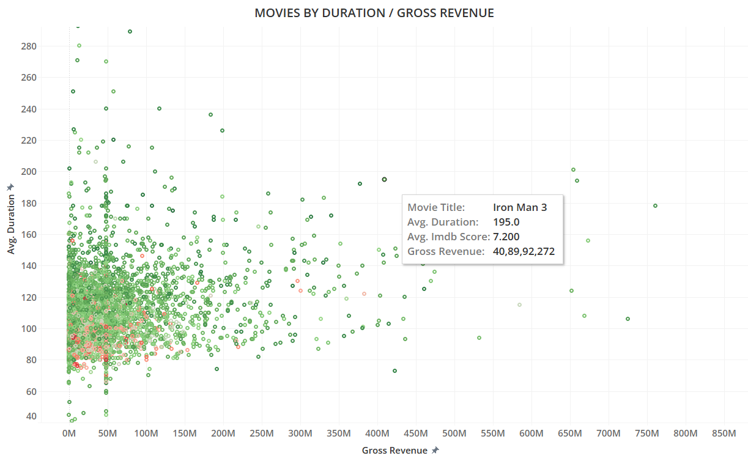

3.HOW HAS THE NUMBER OF MOVIES PRODUCED CHANGED OVER THE YEARS

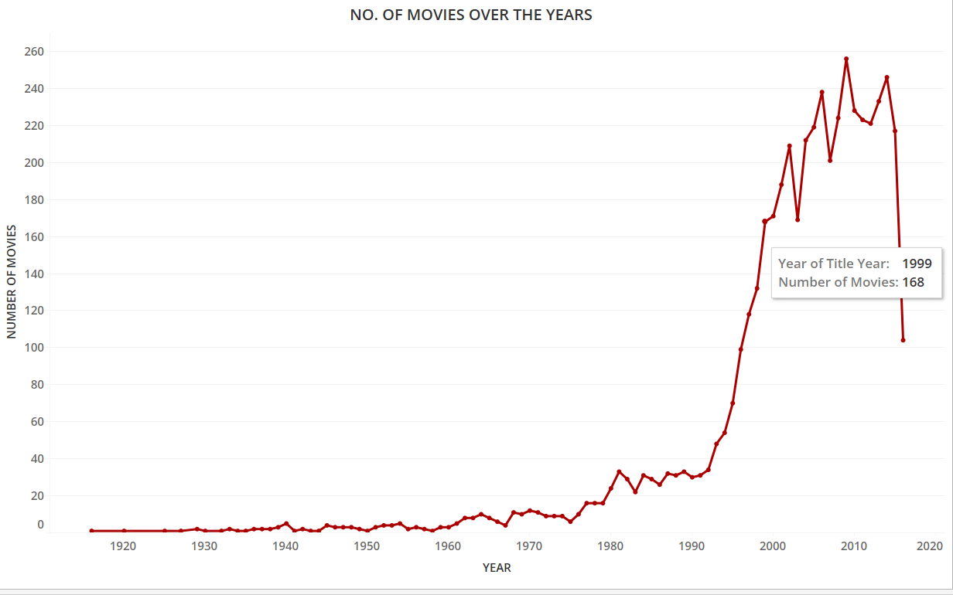

4.WHAT GENRE DOES THE DIRECTOR FOCUS MORE UPON AND DOES THE IMDB SCORE GOVERN THIS ?

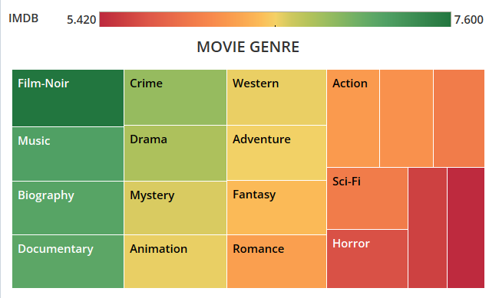

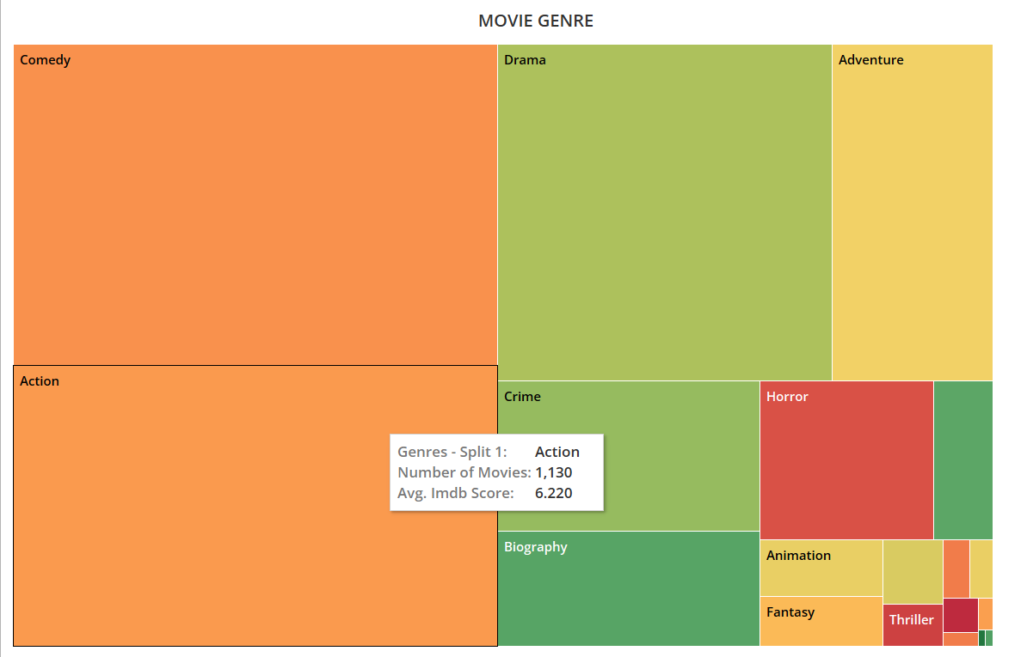

5.DOES THE IMDB SCORE PLAY A ROLE IN THE MOVIE LIKENESS AMONGST THE PUBLIC

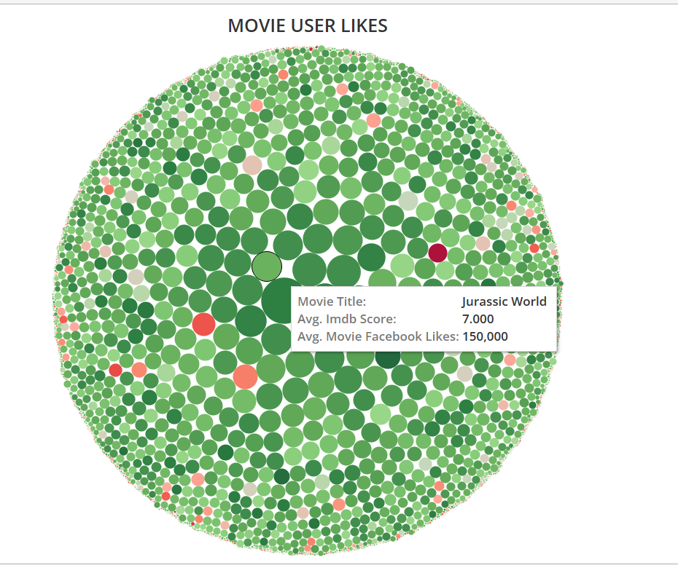

6. WHAT IS THE DISTRIBUTION OF THE MOST CASTED ACTORS BY THE DIRECTORS ACCORDING TO THE GROSS REVENUE OF THE MOVIE

